Owala Proposal
Slides link: Owala Proposal

Background
Our company is Owala. Owala is a Singapore based drinkware launched in 2022, best known for its innovative reusable water bottle. Furthermore, our company will be focusing on making hydration fun and convenient while promoting sustainability by reducing the needs for single used plastic. Not only that, Owala supports sustainability by reducing the dependence on disposable plastic bottles and using long lasting recyclable materials like stainless steel and recyclable plastic. Our company has used scratch and quizzes in our project which aims to showcase our company’s commitment to environmental responsibility white educating users on the importance of sustainable hydration habits. The games are created on scratch and the quizzes will be used to test the knowledge of the users about Owala, sustainability and eco-friendly habits.

Company
The company we have chosen is Owala, it is a company known for creating durable, stylish, and convenient water bottles used by students, athletes, and everyday consumers.
Many people still use disposable bottles, contributing to unnecessary waste. Therefore, Owala’s mission is to promote a healthier planet by encouraging people to reduce single-use plastic waste through the use of durable, reusable water bottles.

Even though Owala promotes eco-friendly products, there are still challenges they face such as consumers being unaware of how much plastic waste is being generated, which is 400 million tonnes yearly, and consumers have difficulty remembering to bring reusable bottles daily due to the inconvenience for them and not having an eco-friendly mindset.

Therefore, our scratch application can be used to educate and encourage users about plastic waste and how reusables make a difference from our games and quizzes.

Mission: promote a healthier planet by encouraging people to reduce single-use plastic waste through the use of durable, reusable water bottles.

Moto: “Refill. Reuse. Refresh”

Requirements
Our Scratch application requires three core components: the Eco Path Game, Catch the Owala Game, and a Think Green with Owala sustainability quiz. The Eco Path Game must allow players to make daily-life choices, with each decision increasing or decreasing a sustainability score and triggering visual feedback such as a bright or darkening environment. Catch the Owala requires a “falling-items” system where players identify sustainable products by catching Owala bottles and avoiding plastic ones, with increasing speed and difficulty across levels. The quiz must display random sustainability questions, track scores, and provide immediate feedback with short eco-tips.
Non-functionally, the application must be easy to navigate, visually clear, and consistent with Owala’s branding. It must run smoothly on Scratch, use readable text and large icons, and provide a simple and engaging user experience. Overall, these requirements ensure that the app effectively educates users on sustainability while supporting Owala’s mission to reduce single-use plastic waste.

Tools & Technologies

The main platform we will be using is scratch which provides a visual, block-based programming environment suitable for creating interactive applications with animations, user controls, and logical functions, additional tools will be used to support development is the Owala website where we get our ideas and inspiration. ChatGPT will be used as a support tool to generate ideas, refine project concepts, debug logic, improve written content, and assist with
explanations during the development process. It helps streamline planning and problem-solving but does not replace Scratch as the main development framework.

Owala Project Schedule Timeline

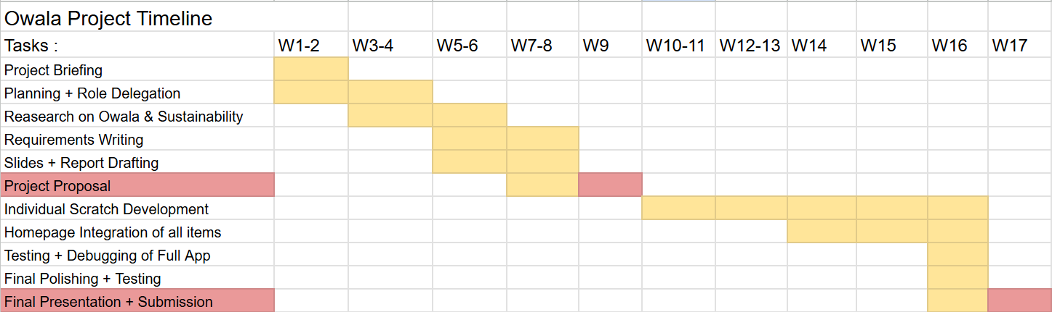
Our project progressed through a structured timeline to ensure consistent development and teamwork. Week 1–2 focused on the project briefing, followed by planning and role delegation. In Week 3–4, we conducted research on Owala and environmental sustainability to guide our solution. Week 5–6 were dedicated to writing the system requirements, ensuring the team had a clear understanding of the app’s features and goals. During Week 7–8, we developed our project slides and reports in preparation for the Week 9 proposal presentation. Individual Scratch development took place from Week 10–13, where each member worked on their assigned components, including the homepage, games, and quiz. Integration and full-app testing occurred in Weeks 14–16 to ensure smooth navigation and consistent design. Finally, Week 17 was reserved for polishing our work and completing the final presentation and submission.

Proposed Solution
1st Game
Name: The Eco Path

Overview: Players go through decision making in their daily life.
(E.g. Bring Owala bottle to school OR buy plastic bottle)

Objective: Players have to choose the most sustainable answer.
(E.g. choosing to bring Owala bottle to school instead of buying plastic bottle)
Each choice affects your sustainability score.
Choosing the wrong choice will result in the sky turning darker.

Condition to win: Reach the end of the day with a high sustainability score.
Condition to lose: Sustainability score drops below a certain amount of level.

Game example:
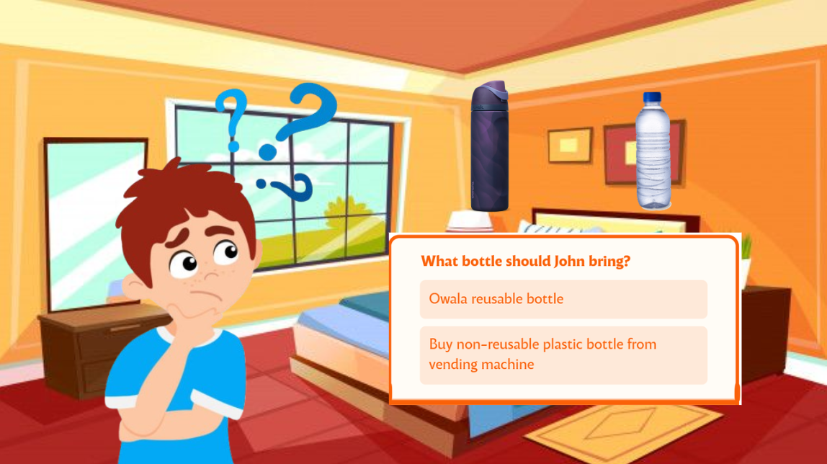

2nd Game
Name: Catch the Owala
Overview: Players must catch the Owala bottles into the bin and avoid the plastic bottles.
Objective: players identify which one is a sustainable product.
Condition to win:
level 1 - catch all 5 owala bottles, speed 1x
Level 2- catch 10 owala bottles, speed 1.5x
Level 3- catch 15 owala bottles, speed 2x
Condition to lose:
Level 1 - catch more than 5 plastic bottles
Level 2- catch more than 3 plastic bottles
Level 3 - catch more than 2 bottles

Game example:
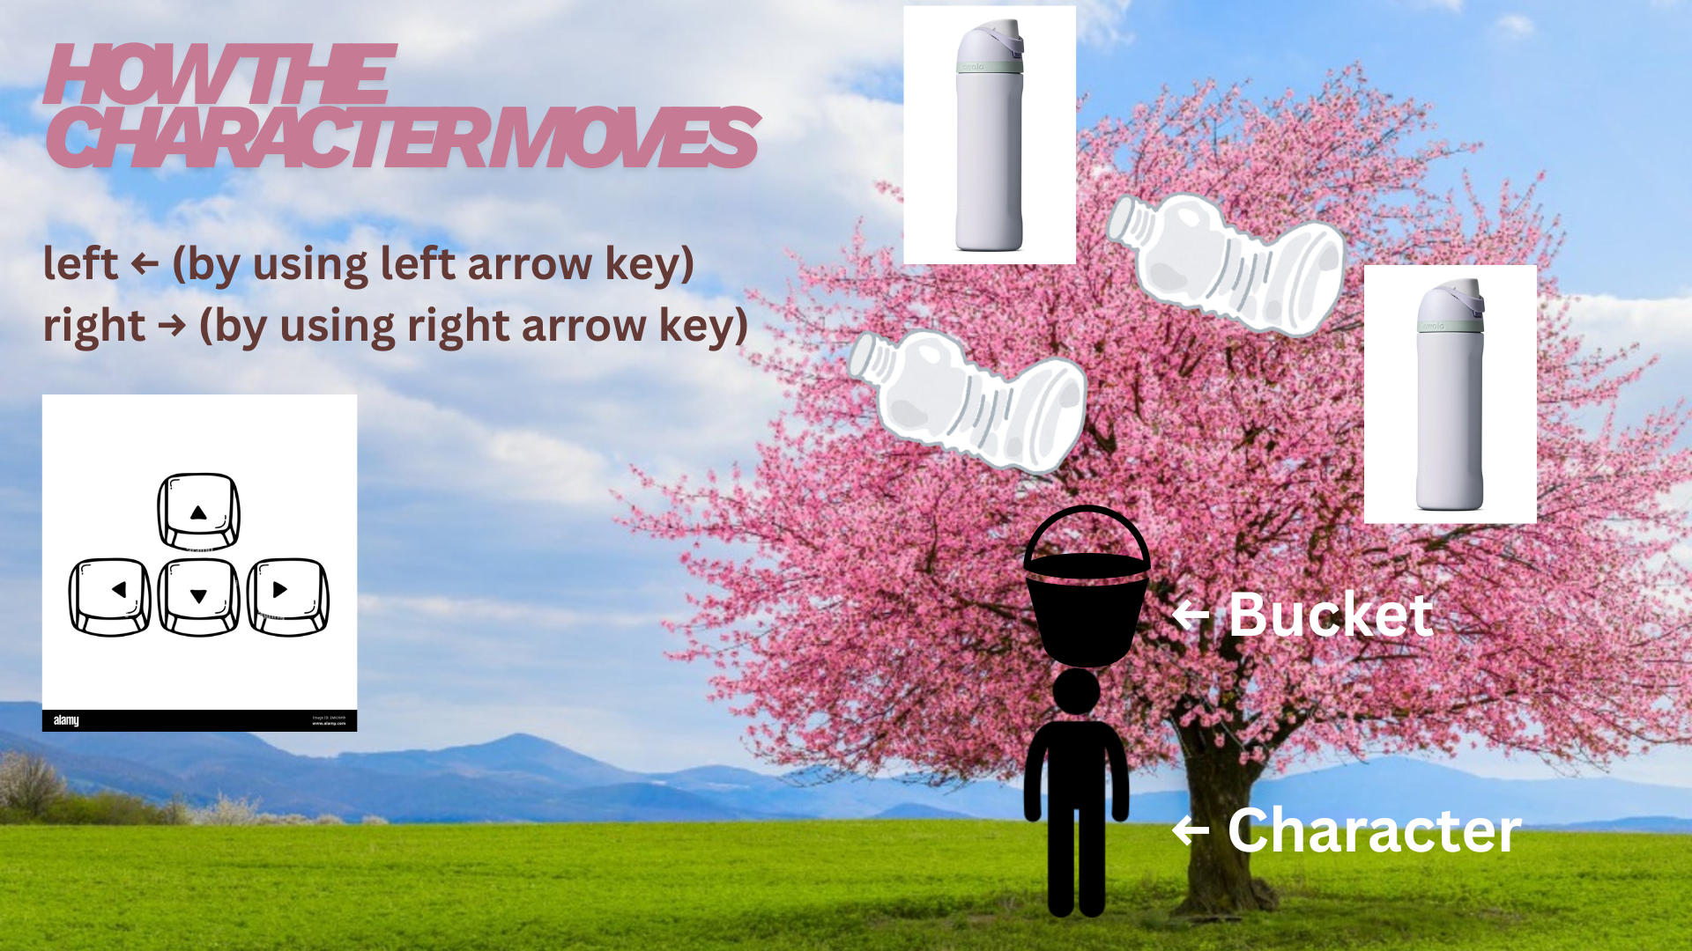

Homepage
An interactive, simple & navigable profile that conjoints all games & quiz together to improve overall user experience.

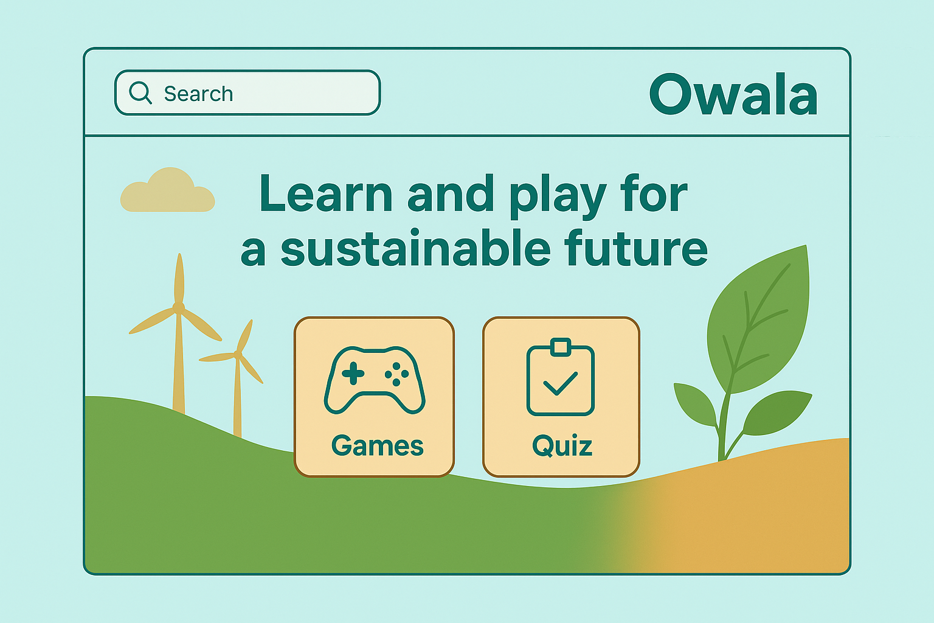

Quiz
Name: Think Green with Owala
Overview: Users must answer all 10 questions about Owala water bottles, sustainability and eco friendly habits.

Condition to win: Get 5 or more correct answers
Condition to lose: Get 4 or less correct answers

